BIO short version
Carrying on his Father’s legacy and band, “Buckwheat Zydeco Jr.” now leads the bands in his legendary father’s footsteps. Growing up at his Father’s side while he played festivals with a host of rock and pop musicians, including Eric Clapton, Paul Simon, U2, Willie Nelson, Robert Plant and Keith Richards, Buckwheat Zydeco, Jr. carried the Louisiana standard of Zydeco music throughout the country.
The Legendary Ils Sont Partis Band derived from the Late Great Stanley Dural also known as Buckwheat Zydeco. This two times Grammy Winners and one time Emmy Award Winner band has performed over 2,500 shows and a host of television appearances. (David Letterman,CBS Morning News, Good Morning America to name a few). They just won the Grammy Award 2024 and 2 Best of the Beat Awards as Best Zydeco Artist and Best Zydeco Album.
The Creole cousin of jazz, Zydeco music will have you up dancing in the isles, in your kitchen, in your living room, no matter your age or abilities; it’s family-festive music.

Photos

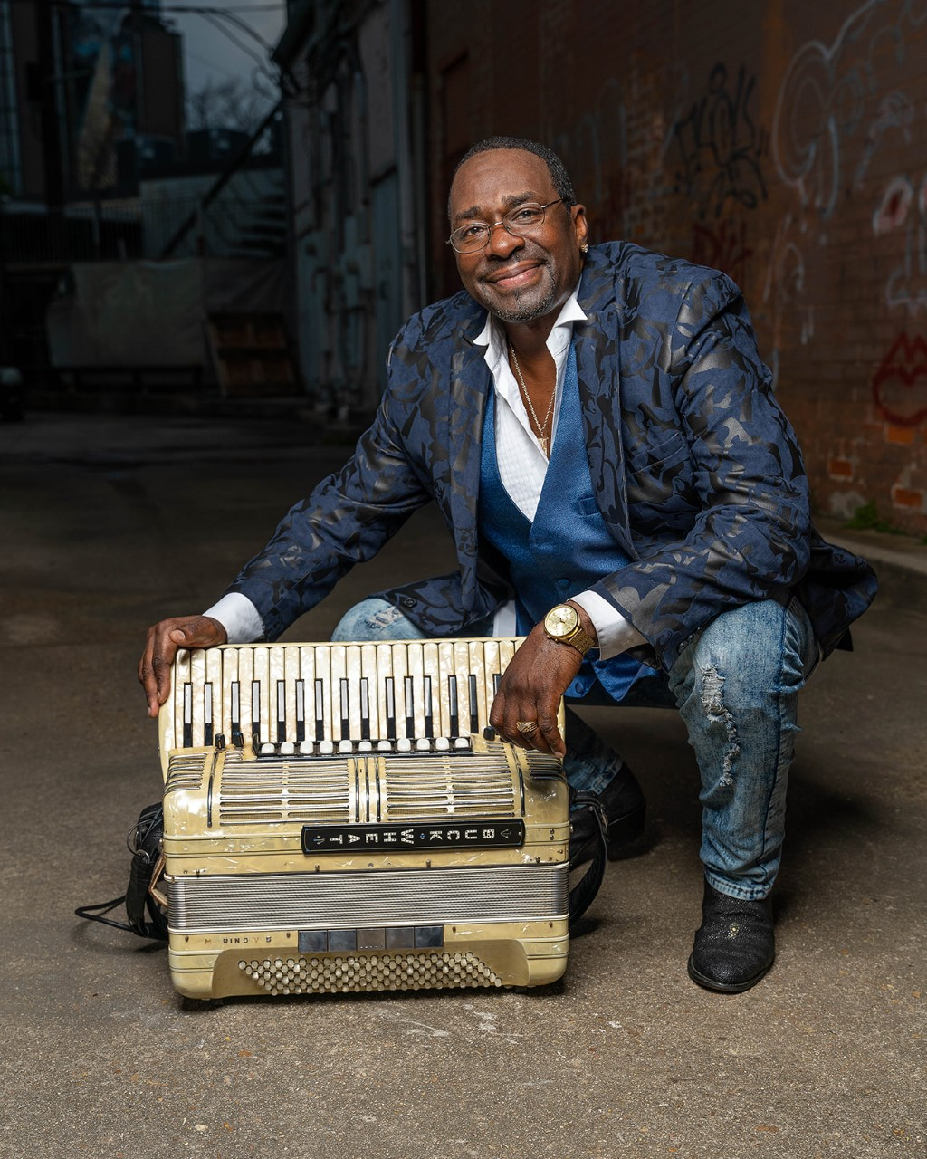

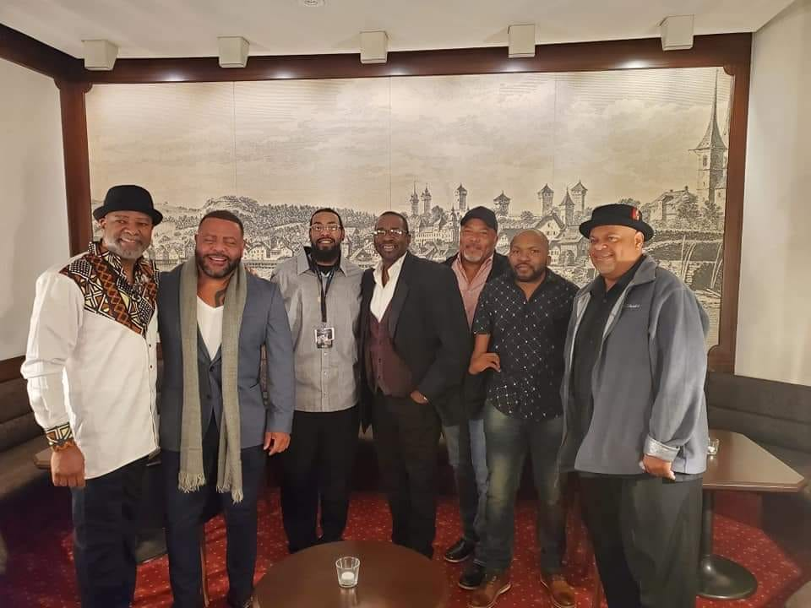
PRESS REVIEW
One of the best bands in America.
– The New York Times
COMMENTS
Looking back at a wonderful 27th LUCERNE BUES FESTIVAL, It’s been a special privilege presenting such an outstanding band as Buckwheat Zydeco Jr. & the Ils Sont Partis Band on our stage. Their performance was top notch and had been celebrated by a delighted and enthusiastic audience. I’m sure that both, the crowd and the organizers will never forget their superb show. Thanks to the band for being part of our festival family.
Dan Mebold , Artistic Director 2022 for LUCERNE BLUES FESTIVAL, Lucerne, Switzerland.

Stage plot and Tech rider
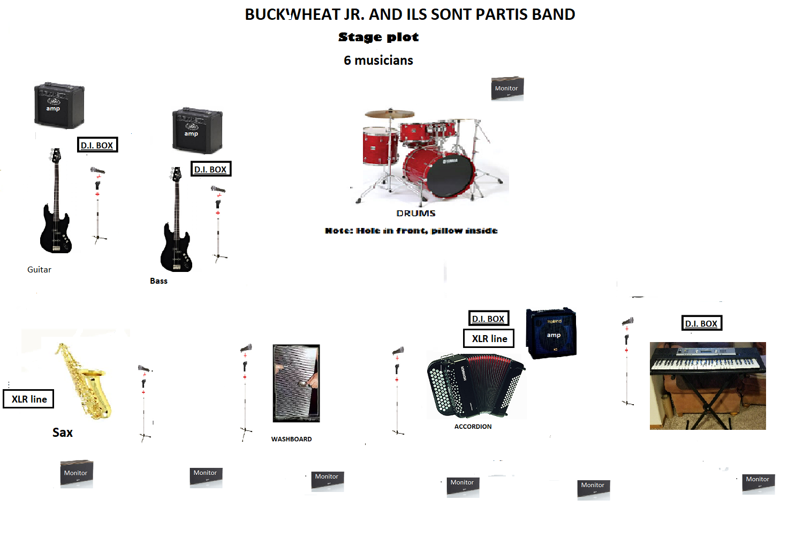

Buckwheat Zydeco Jr. and The Legendary Ils Sont Partis Band
6 musicians
TECH-RIDER (Purchaser supply backline: amps, keyboard and drums)
1. For the Accordion: One D.I. Box + one Shure SM-58 or equivalent vocal mic. + XLR line
2. For the Guitar: One D.I. Box + one Shure SM-58 or equivalent vocal mic. + Fender Twin amp
3. For the Bass: One D.I. Box + one Shure SM-58 or equivalent vocal mic. + Ampeg bass rig
4. For the Washboard: One Shure SM-58 or equivalent multi-purpose (voc./instr.) mic.
5. For the Sax: one Shure SM-58 or equivalent vocal mic. + XLR line
6. For the keyboard : One D.I. Box + one Shure SM-58 or equivalent vocal mic. PLUS Hammond B3 OR Hammond Xk1 are Xk2 keyboard
7. Drums: 5 pieces standard Drum kit Yamaha or Pearl + cymbals + appropriate drum and cymbal miking for the performance area so that all drums pieces can be clearly heard.
Buckwheat Zydeco Jr. plays keyboard and accordion.
Note: Pillow inside: Hole in Front.
PLUS 6 MONITORS

Contact: Lucy Bertrand
productionslb@hotmail.com

Buckwheat Zydeco Jr. and The Legendary Ils Sont Partis Band
6 musicians
TECH-RIDER
(ARTIST supply backline: amps, keyboard and drums)

1. For the Accordion: One D.I. Box + one Shure SM-58 or equivalent vocal mic. + XLR line

2. For the Guitar: One D.I. Box + one Shure SM-58 or equivalent vocal mic.

3. For the Bass: One D.I. Box + one Shure SM-58 or equivalent vocal mic.

4. For the Washboard: One Shure SM-58 or equivalent multi-purpose (voc./instr.) mic.

5. For the Sax: one Shure SM-58 or equivalent vocal mic. + XLR line

6. For the keyboard : One D.I. Box + one Shure SM-58 or equivalent vocal mic.

7. Drums: Artist supply his 5 pieces standard Drum kit. Venue supply appropriate drum and cymbal miking for the performance area so that all drums pieces can be clearly heard.
Note: Pillow inside: Hole in Front.
PLUS 6 MONITORS

Contact: Lucy Bertrand
productionslb@hotmail.com

